SHREYA PANCHAL
Assignment-8: Auto-Scaling Concept show auto-Scaling Works to handle Varying Workloads. Configure auto-Scaling groups based on traffics metrics.
1.Set up a free-tier AWS account (or use an AWS Cloud sandbox) and launch a basic EC2 instance that serves a static HTML page. Document the steps you took and the public URL of your instance.
Answer: Steps Performed:
- Logged in to AWS Management Console.
- Launched an Ubuntu EC2 instance (Free Tier).
- Configured the Security Group to allow SSH (22) and HTTP (80).
- Connected to the instance using EC2 Instance Connect.
- Updated the server: #sudo apt update
- Installed Apache: #sudo apt install apache2 -y
- Created a custom index.html file in /var/www/html/.
- Restarted Apache: #sudo systemctl restart apache2
- Verified the website in a web browser using the public IP.
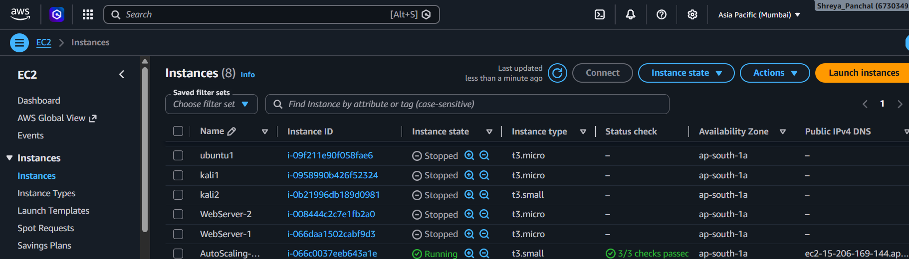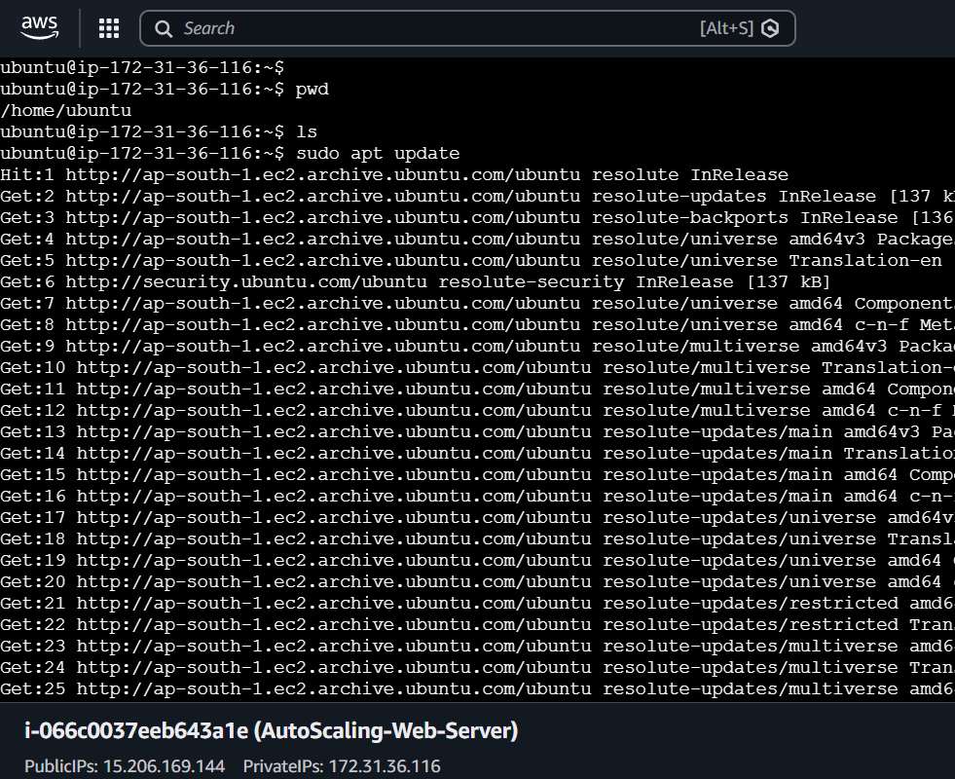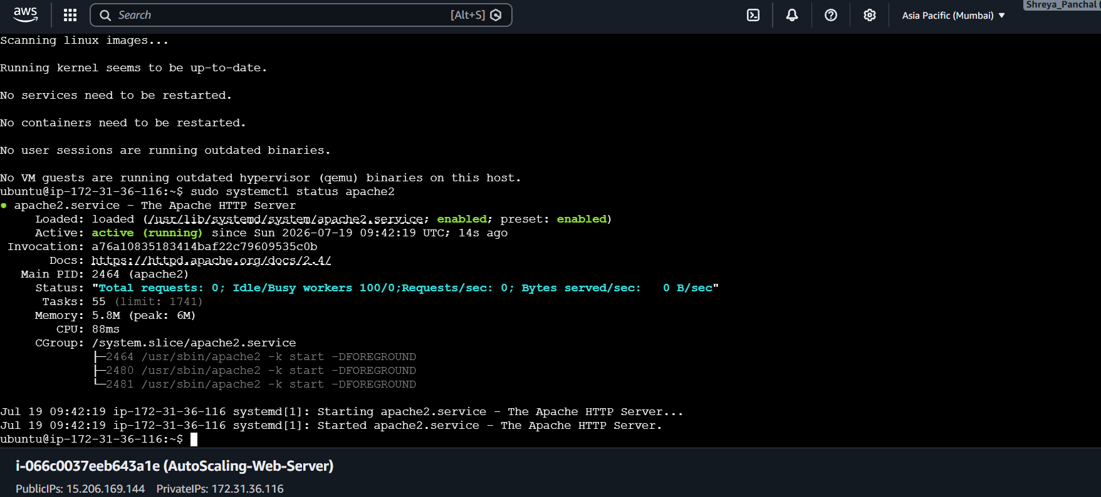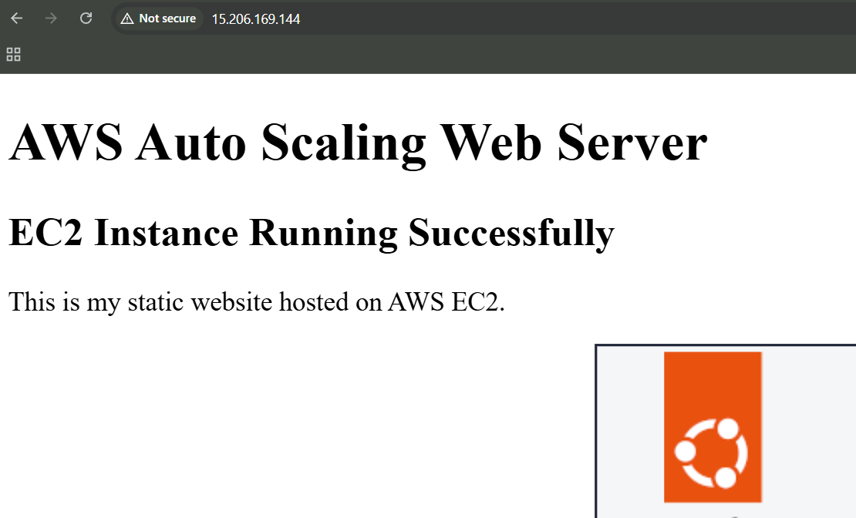

2. Create an Auto Scaling Group in AWS that maintains a minimum of 1 and a maximum of 3 EC2 instances for your web server. Set the scaling policy to add a new instance if CPU utilization goes above 60% for 5 minutes.<br><br><em><strong>Hint:</strong> Use the AWS Management Console's Auto Scaling Groups section and attach your EC2 launch template or configuration.</em>
Answer: Steps
Step 1: Create an AMI from the existing EC2 web server.
Step 2: Create a Launch Template using the created AMI, select t2.micro/t3.micro, key pair, and security group.
Step 3: Go to EC2 → Auto Scaling Groups and click Create Auto Scaling Group.
Step 4: Select the Launch Template, VPC, and Public Subnet(s).
Step 5: Configure the capacity:
- Desired Capacity: 1
- Minimum Capacity: 1
- Maximum Capacity: 3
Step 6: Configure the scaling policy:
- Policy Type: Target Tracking
- Metric: Average CPU Utilization
- Target Value: 60%
- Warm-up Time: 300 Seconds (5 Minutes)
Step 7: Review the settings and click Create Auto Scaling Group.
Result:
The Auto Scaling Group was created successfully. It maintains 1 EC2 instance and automatically scales up to 3 instances when CPU utilization exceeds 60% for 5 minutes.
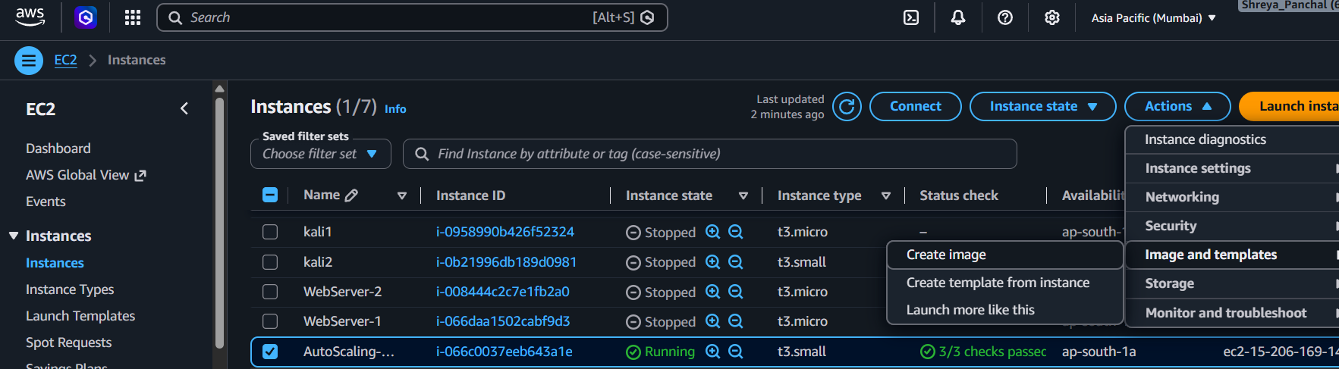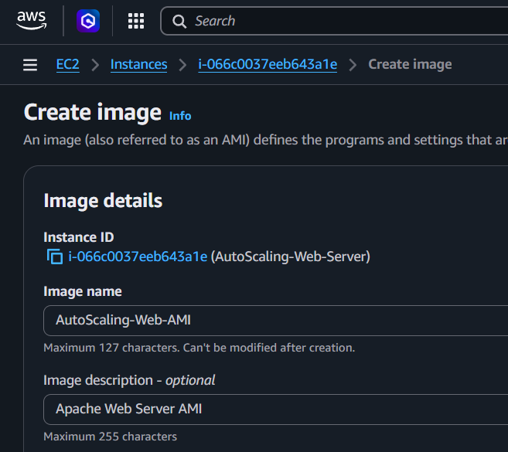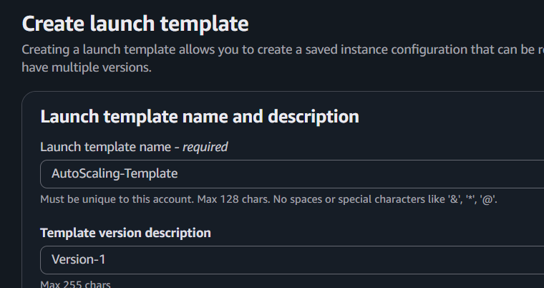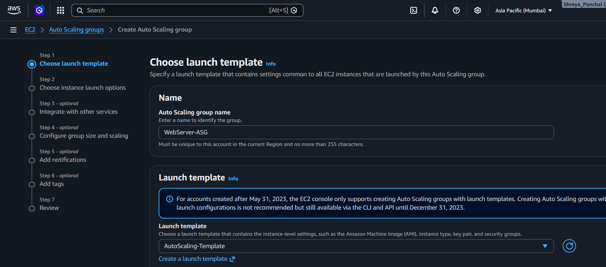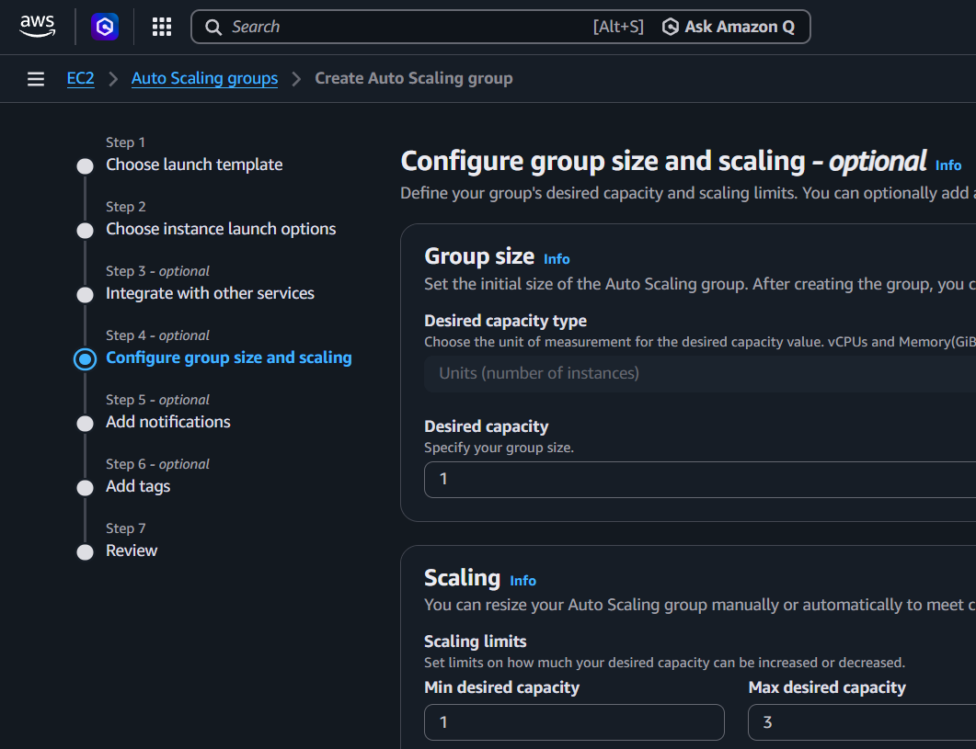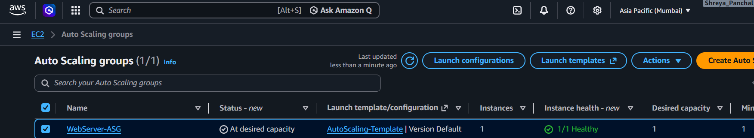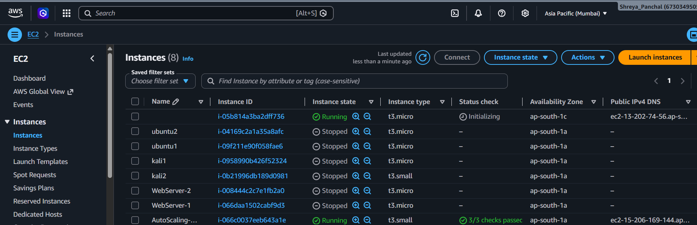

3. Simulate increased traffic to your web server by using an online load testing tool (such as Loader.io or k6) and observe if the Auto Scaling Group launches additional instances when CPU usage spikes.
Answer: Steps:
Step 1: Copy the Public IP of the web server: http://15.206.169.144
Step 2: Open Loader.io (or use k6) and create a new test.
Step 3: Verify the website by adding the verification file to the web server (if using Loader.io).
Step 4: Configure the load test:
- Clients: 50
- Duration: 5 Minutes
- Target URL: http://15.206.169.144
Step 5: Start the load test to generate heavy traffic on the web server.
Step 6: Open AWS Console → EC2 → Auto Scaling Groups → Activity and monitor the scaling events.
Step 7: Go to EC2 → Instances and verify that a new EC2 instance is launched automatically when CPU utilization exceeds 60%.
Result:
The load test generated high traffic on the web server. When CPU utilization exceeded 60% for 5 minutes, the Auto Scaling Group automatically launched additional EC2 instance(s). The application remained available and handled the increased workload successfully.
4. After scaling up, reduce the simulated load and verify that the Auto Scaling Group scales the number of instances back down to the minimum. Take screenshots of the scaling activity history as evidence.
Answer: Scale Down Verification
Step 1: Stop the load test in Loader.io (or k6) after the Auto Scaling Group has launched additional EC2 instances.
Step 2: Wait 5–10 minutes for the CPU utilization to decrease below the scaling threshold.
Step 3: Open AWS Console → EC2 → Auto Scaling Groups → Activity.
Step 4: Verify that the Auto Scaling Group automatically terminates the extra EC2 instances and returns to the minimum capacity.
Expected Capacity:
- Minimum: 1
- Desired: 1
- Maximum: 3
Result:
After the load test was stopped, CPU utilization decreased. The Auto Scaling Group automatically terminated the additional EC2 instance(s) and scaled back to the minimum capacity of 1 instance, confirming that the scale-in policy worked successfully.

5. Use ChatGPT or another AI tool to generate a list of 3 real-world scenarios (from apps like Zomato, Flipkart, or Book My Show) where auto-scaling is essential, and explain in your own words why auto-scaling helps in each scenario.
Answer: Real-World Scenarios Where Auto Scaling is Essential
1. Zomato
Scenario: During lunch and dinner hours, thousands of users place food orders at the same time.
Why Auto Scaling Helps: Auto Scaling automatically launches additional servers to handle the increased traffic, ensuring the app remains fast and responsive. When traffic decreases, it removes extra servers to reduce costs.
2. Flipkart
Scenario: During Big Billion Days or festive sales, millions of customers browse products and place orders simultaneously.
Why Auto Scaling Helps: Auto Scaling increases the number of servers to handle the high demand and prevents website crashes. After the sale, it scales down the servers to save infrastructure costs.
3. Book My show
Scenario: When tickets for a popular movie or concert become available, many users try to book at the same time.
Why Auto Scaling Helps: Auto Scaling adds more EC2 instances to manage the sudden spike in traffic, allowing users to book tickets smoothly without delays or downtime.
Conclusion:
Auto Scaling automatically adjusts the number of servers based on user traffic. It improves application performance, maintains high availability, and reduces infrastructure costs by scaling up during peak demand and scaling down when demand is low.

